QuickStop Essentials
CPAN-228 Web Application Development
Assignment 0: Project Planning & GitHub Setup

0. Group Name: QuickStop Devs
Amber Forrest - “I’m Amber, and I enjoy problem solving and applying logical thinking when building software solutions.”
Garv Dugh - “”
Murat Sasmaz - “”

1. Category 1: E-Commerce Platform
Scenario: Our idea is QuickStop Essentials. The app will be a mobile-friendly e-commerce platform for people who are on the go and need something urgent. Like drivers, students, commuters, travellers, or anyone who needs quick products during the day. It is not just a normal online store, but is a quick pickup app for urgent daily needs.

For example, if someone is driving and suddenly needs motor oil, phone charger, windshield washer fluid, or personal items like deodorant, shampoo, toothpaste, or maybe basic clothes like socks or hoodie then they can open the app, check nearby stock, place an order for their items, and pick it up their order quickly from a pickup location.

Core domain: We will have products, brands, categories, inventory, pickup locations or distribution centres, orders, order items, and users

We will keep the products in 4 basic categories:
- Auto Essentials: motor oil, oil filter, air filter, wiper blades, windshield washer fluid, phone charger
- Personal Care: shampoo, deodorant, perfume, toothpaste, hand sanitizer, wet wipes
- Tech Essentials: USB-C cable, iPhone cable, power bank, phone holder, earbuds
- Basic Clothing: socks, t-shirts, hoodies, gloves, winter hats

- The main idea is that users can open the app, choose a nearby pickup location, see what products are currently in stock, place an order with requested items, and pick their order up quickly.

To summarize the scenario with entities:
USER places ORDER(S)
ORDER contains ORDER_ITEM(S)
PRODUCT belongs to BRAND and CATEGORY
INVENTORY connects PRODUCT and PICKUP_LOCATION

- Why Choose This: We chose this idea as it fits our assignment requirements including CRUD operations and real world complexity of wanting to quickly urgent daily needs. Also, we will be able to incorporate the use of Spring Boot, Thymeleaf, JPA, database relationships, login/security.

2. Domain Model:
Entities: USER, PRODUCT, BRAND, CATEGORY, INVENTORY, PICKUP_LOCATION, ORDER, ORDER_ITEM

ER Diagram:
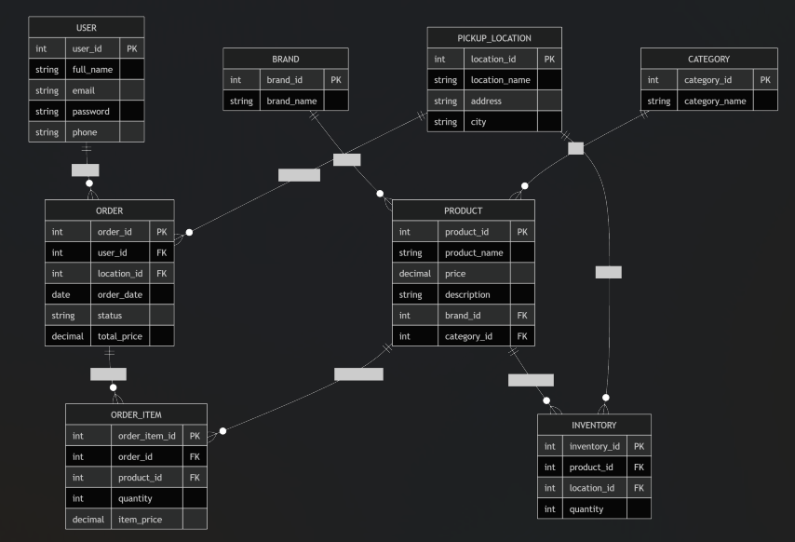
3. GitHub Repository
(not yet completed)

4. UI Layout: Wireframes – QuickStop Essentials

1. Home Screen
------------------------------------------------
QuickStop Essentials
------------------------------------------------

Need something fast today?

Select Pickup Location:

( ) Downtown Toronto QuickStop
( ) North York QuickStop
( ) Scarborough QuickStop

Categories

[ Auto Essentials ]
[ Personal Care ]
[ Tech Essentials ]
[ Basic Clothing ]

[ View Products ]

------------------------------------------------

2. Product List Screen
------------------------------------------------
Products Available
------------------------------------------------

Location:
Downtown Toronto QuickStop

[ Search Products ]

Auto Essentials

Motor Oil
$12.99
In Stock: 8
[ Add to Cart ]

USB-C Car Charger
$14.99
In Stock: 12
[ Add to Cart ]

Phone Holder
$19.99
In Stock: 5
[ Add to Cart ]

[ View Cart ]

------------------------------------------------

3. Product Details Screen
------------------------------------------------
Product Details
------------------------------------------------

Product:
Motor Oil

Brand:
Castrol

Category:
Auto Essentials

Price:
$12.99

Available Stock:
8 Units

Description:
High-quality motor oil for quick vehicle
maintenance.

Quantity:
[-] 1 [+]

[ Add to Cart ]

------------------------------------------------

4. Shopping Cart Screen
------------------------------------------------
Your Cart
------------------------------------------------

Pickup Location:
Downtown Toronto QuickStop

Motor Oil x1 $12.99

USB-C Charger x1 $14.99

--------------------------------
Total: $27.98
--------------------------------

[ Place Order ]

------------------------------------------------

5. Order Confirmation Screen
------------------------------------------------
Order Confirmed
------------------------------------------------

Thank You!

Order Number:
1001

Status:
Ready for Pickup

Pickup Location:
Downtown Toronto QuickStop
100 King St W
Toronto, ON

Items:
• Motor Oil
• USB-C Charger

[ Return Home ]

------------------------------------------------

